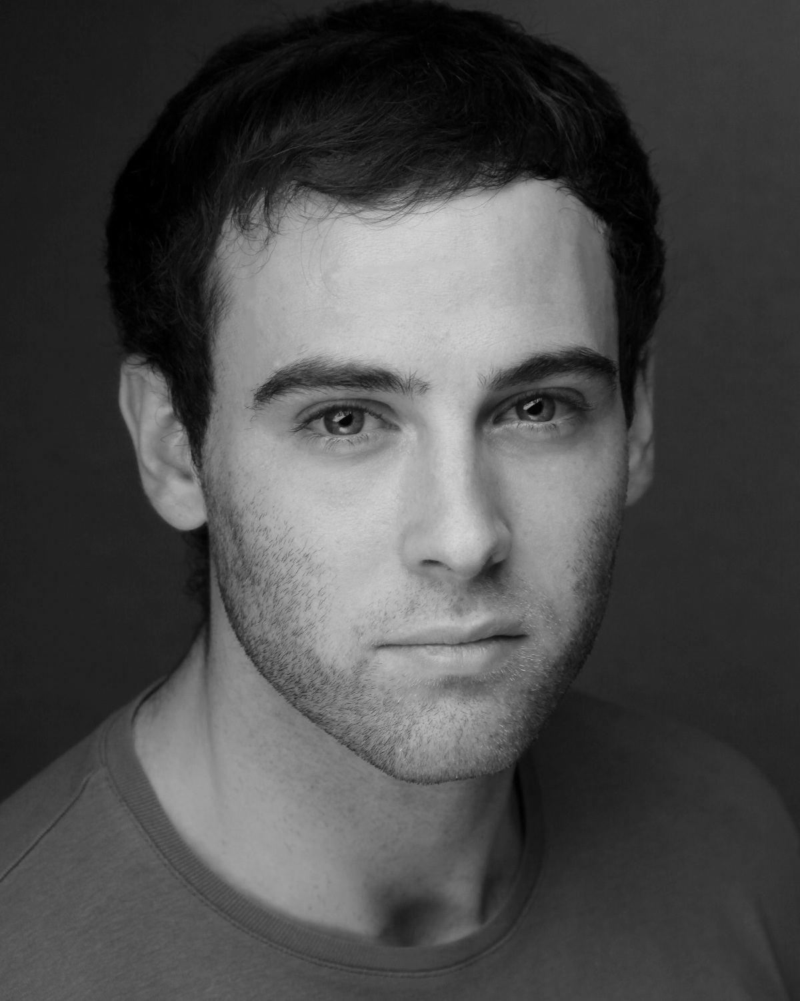Lewis Davidson
Address: Southwark, London. SE1
Website: http://www.LewisDavidson.co.uk
Email: Contact@LewisDavidson.co.uk
Equity Number: 311498
Spotlight Link: http://www.spotlight.com/1899-1270-0743
Height: 1.80m
Hair: Brown
Eyes: Blue
Weight: 62kg
Accents: RP, Aberdeen Scotland*, General Scottish, Northern Irish, Southern American, American
Role Playing Age: 20-29
Skills: Full UK Driving License; CRB Checked; Contemporary Dance; Break Dance; Leading Workshops; Classical Acting; Physical Theatre; Clown; Trapeze; Fire Breathing; Human Blockhead; Commedia Dell’ Arte; Naturalism; Devising.
Training: 2007-2010 – Kingston University, BA (Hons) Drama, Upper Second Class Honours
2006-2007 – Aberdeen College, HNC Acting and Performance
Year | Genre | Role | Production | Company | Director | Theatre
2011 | Stage | Various | Re-Birth of Coney Island | Tosarelli Productions | Francesca  Tosarelli | Outdoor
2011 | Stage | Duke Alba | Don Carlos | Lazarus Theatre Company | Ricky Dukes | Blue Elephant Theatre
2011 | Commercial | Model / Dancer / Fire Breather | Freddy Clothing Campaign | Freddy Clothing | Luigi Pane
2011 | Stage | Various | Warriors | Shadow Road | Emma Farlow | St Marys, Barnes
2011 | Stage | One Man Show | Sideshow | Backhand Theatre | Jake Linzey | C Venues, Edinburgh Festival
2011 | Stage | Various | Tales of Edgar Allan Poe | Backhand Theatre | Kate Huxley Golden | C Venues, Edinburgh Festival
2011 | Stage | Ferdinand | The Tempest | Backhand Theatre | Jake Linzey | C Venues, Edinburgh Festival
2011 | Stage | Ronald Adams | The Hitch-Hiker | Shadow Road | Emma Farlow | OSO Centre
2011 | Stage | Banquo | Macbeth | Lazarus Theatre Company | Ricky Dukes | Blue Elephant Theatre
2011 | Film | Boxer | Punching Above You Weight | London Film School | Uri Stramer
2010 | Stage | Marat | Marat/Sade | Europa Theatre | Eric Douchin | The Courtyard, London
2010 | Stage | Melchior | Spring Awakening | KUDOS | Elouise West | C Central, Edinburgh
2010 | Stage | Judge | Revengers Tragedy | Picklock | Frank Whately | The Rose, Kingston
2010 | Stage | MacDuff | Macbeth | KUDOS | Andrew Currums | Reg Bailey Theatre
2010 | Stage | Melchior | Spring Awakening | KUDOS | Elouise West | Reg Bailey Theatre
2009 | Dance Show | Break Dancer | Fusion | KuDance | Joshua Carron | Performing Arts Centre, Kingston
2009 | Stage | Roger | The Balcony | Happy House Productions | Sophie Cook | Arthur Cotterell Theatre, ERBA Valence France
2009 | Stage | Ryan | Sidings | Not Applicable Theatre | Tom King | The Rose, Kingston
2009 | Stage | Don Pedro | Much Ado About Nothing | KUDOS | Jasmine Cole | Reg Bailey Theatre
2009 | Stage | Priest | The Blind | KUDOS | Ross Halford | Reg Bailey Theatre
2009 | Street Theatre | El Capitano | Commedia Dell’ Arte | Comedy Errors | Steve Knapper | Bentall Centre, Kingston
2008 | Stage | Ariel | The Pillowman | KUDOS | Terrie-May McNulty | Reg Bailey Theatre
2008 | Musical Tour | Governor Noble | Lottie | Garidge Theatre | Rhona Mitchell | His Majesty’s Theatre
2007 | Short Film | Harry | Letting Go | Shadow Films | Lorna Berridge
2007 | Stage | Lysander | A Midsummer Night’s Dream | Garidge Theatre | Rhona Mitchell | Lemon Tree Theatre
2007 | Short Film | Hugh | Serious Fun | Shadow Films | Lorna Berridge
2007 | Stage | Napoleon | Animal Farm | ABCOL | Vicki Jamieson | Lemon Tree Theatre
2006 | Television | Martin | Hollyoaks,  On The Pull | Lime Pictures | David Richardson
2005 | Commercial | Jamie | Alcohol Abuse | Think First | Sarah Hunter
2005 | Stage | Sebastian | Twelfth Night | ABCOL | Lynne State | Harlaw Theatre
Credits:

